St. Mary’s Parish
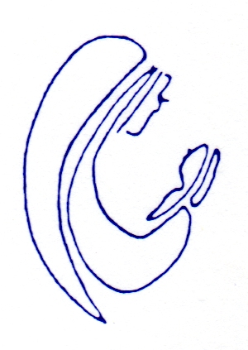
27 Chauncey St, Lancefield,
Victoria 3435
Telephone: 5429 2130
Email: lancefield@cam.org.au

SACRAMENT REGISTRATION
Sacrament: Reconciliation / Eucharist / Confirmation
Child’s full name:
Date of Birth:
Residential address:
Home phone:
Mobile:
Email address:
Name of current school & year level:
Date / Place of baptism:
Parent Name:

